FOR MORE INFORMATION:
Annie Miller
BRAVE Public Relations
404.233.3993
amiller@emailbrave.com

Tickets for the Atlanta Premiere of
Anastasia
Go On Sale Sep. 16

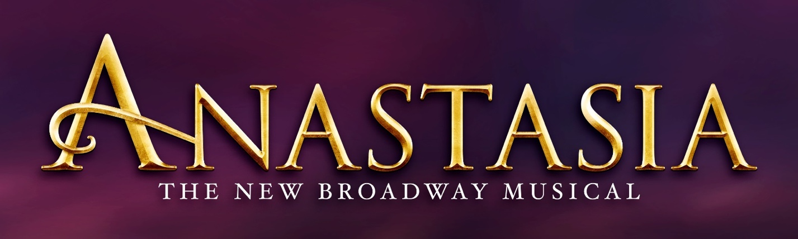

ATLANTA (Sept. 7, 2022)- Regions Bank Broadway in Atlanta announced today that the individual tickets for the tour of ANASTASIA will go on sale Sept. 16. Tickets will be available at the Fox Theatre box office (660 Peachtree Street NE, Atlanta, Georgia 30308), by visiting foxtheatre.org/Anastasia or by calling (855)-285-8499. Group orders of 10 or more may be placed by calling the Fox Theatre at (855)-285-8499.

Playing as part of Regions Bank Broadway in Atlanta’s 2022/2023 season, the Atlanta premiere engagement of ANASTASIA will play Dec. 6-11. The performance schedule is as follows:
Tuesday – Thursday 7:30 p.m.
Friday 8 p.m.
Saturday 2 p.m., 8 p.m.
Sunday 1 p.m., 6:30 p.m.

From the Tony Award-winning creators of the Broadway classic Ragtime and inspired by the beloved films, ANASTASIA is the new Broadway musical that’s “one of the most gorgeous shows in years!” (New York Observer). This dazzling show transports us from the twilight of the Russian Empire to the euphoria of Paris in the 1920s, as a brave young woman sets out to discover the mystery of her past. Pursued by a ruthless Soviet officer determined to silence her, Anya enlists the aid of a dashing conman and a lovable ex-aristocrat. Together, they embark on an epic adventure to help her find home, love, and family.

The cast includes Veronica Stern as Anya, Willem Butler as Dmitry, Ben Edquist as Gleb, Gerri Weagraff as Dowager Empress, Bryan Seastrom as Vlad, Madeline Raube as Countess Lily and Leela Chopra and Alexandrya Salazar as Little Anastasia. The ensemble includes Kaitlyn Jackson, Lance Timothy Barker, William Aaron Bishop, Billy McGavin, Louis Brogna, Zachary Bigelow, Thalia Atallah, Alec Lloyd, Amy Smith, Amin Fuson, Victoria Madden, Aidan Ziegler-Hansen, Brooklyn Libao, Rebecca Hartman, Lathan A. Roberts, Sarah Statler and Lauren Teyke.

ANASTASIA features a book by celebrated playwright the late Terrence McNally, a lush, new score by the Tony Award® -winning creators of the Broadway classic Ragtime, Stephen Flaherty (music) and Lynn Ahrens (lyrics), and tour direction by Sarah Hartman based on original direction by Tony Award®-winning director Darko Tresnjak.

The creative team also includes Peggy Hickey (Original Choreographer), Bill Burns (Choreographer), Alexander Dodge (Set Design), Linda Cho (Costume Design), Donald Holder (Lighting Design), Peter Hylenski (Sound Design), Aaron Rhyne (Projection Design), Charles G. LaPointe (Hair/Wig Design), Joe Dulude II (Makeup Design), Tom Murray (Music Supervision), Jeremy Lyons (Music Direction), Doug Besterman (Orchestrations), David Chase (Dance Arranger), and casting by Jason Styres, CSA.

ANASTASIA began performances on Broadway in March 2017 at the Broadhurst Theatre with critics exclaiming “Ahrens and Flaherty have chosen the right moments to musicalize, and their score here sounds complete and full — one of the season’s strongest! (NBC)” and “Smartly adapted by Terrence McNally, Anastasia is a sweeping adventure, romance and historical epic whose fine craftsmanship will satisfy musical-theater fans (Time Out)”.

The show played to sold out audiences on Broadway for more than 3 years before expanding it’s global “Fanastasia” community with productions on tour across North America and in Japan, Spain, Germany and the Netherlands. Globally, the show has been performed more than 2,500 times and sold 3.4 million tickets. Additionally, the show has garnered more than 15 major international awards, including Tony, Drama Desk and Outer Critics Circle awards and Best New Musical in Spain, Germany and the Netherlands.

The original Broadway cast recording is available at BroadwayRecords.com, Amazon.com and iTunes. The 75-minute album includes the Academy Award-nominated favorite “Journey to the Past” alongside new numbers from the show such as “In My Dreams,” “Still” and “My Petersburg.”

Information about the venue’s enhanced health and safety measures can be found on the Fox Theatre website. The health and well-being of audiences, touring productions, staff and all venue personnel remains top priority.

Connect with ANASTASIA online at:
www.anastasiathemusical.com
T @AnastasiaBway
Facebook: AnastasiaBway
Instagram: @AnastasiaBway

###
ABOUT BROADWAY ACROSS AMERICA
Broadway Across America (BAA) is part of the John Gore Organization family of companies, which includes Broadway.com, The Broadway Channel, BroadwayBox.com, Group Sales Box Office and Broadway Brands. Led by 18-time Tony-winning theater producer John Gore (Owner & CEO), BAA is the foremost presenter of first-class touring productions in North America, operating in 48 markets with over 400,000 subscribers. Presentations include Disney’s The Lion King, Wicked, The Book of Mormon and Hamilton. Current and past productions include Ain’t Too Proud, Beautiful, Cats, Chicago, Dear Evan Hansen, Mean Girls, Moulin Rouge! and To Kill A Mockingbird.

The John Gore Organization is the leading presenter, distributor, and marketer of Broadway theater worldwide. Under the leadership of 18-time Tony-winning theater producer and owner John Gore, its family of companies includes Broadway Across America, Broadway.com, The Broadway Channel, BroadwayBox.com, Group Sales Box Office and Broadway Brands. The company presents shows in 48 cities across North America as well as on Broadway, Off-Broadway, London’s West End, Japan, and China. It has won Tony Awards in every producing category as well as numerous other Drama League, Drama Desk and Olivier Awards. The John Gore Organization is committed to supporting theater access and education programs that introduce Broadway to the next generation of audiences and theater professionals.

